[IMA-24] The app doesn´t rotate when i press on "Auto rotate" mode
Created: 11/Sep/24 Updated: 11/Sep/24
Status: | To Do
Project: | Instagram Mobile App

Type: | Bug | Priority: | Medium
Reporter: | Tomer Darmon | Assignee: | Unassigned
Environment: | OS : Android  Device : One Plus 11 5G OS Version : Android 14

Attachments: | 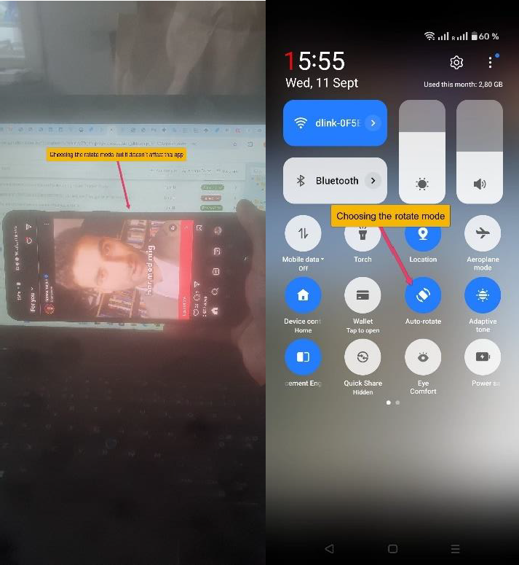
Severity1: | S3 - Major

Description
Steps to Reproduce :
- Swipe down from the top on the screen to access the quick settings
- Press on the option "Auto Rotate" and swipe up the page
- Ener the "Instagram" app
- Rotate your phone on any page from portrait mode to landscape mode
Actual Result :
The app doesn´t rotate after choosing the rotate mode and the screen still stay on portrait mode and not landscape mode when i rotate it.
Expected Result :
I expect the screen to change its view according to the mode I rotated my phone

43

